**Why Is Lease Registration Mandatory for Commercial Properties?**

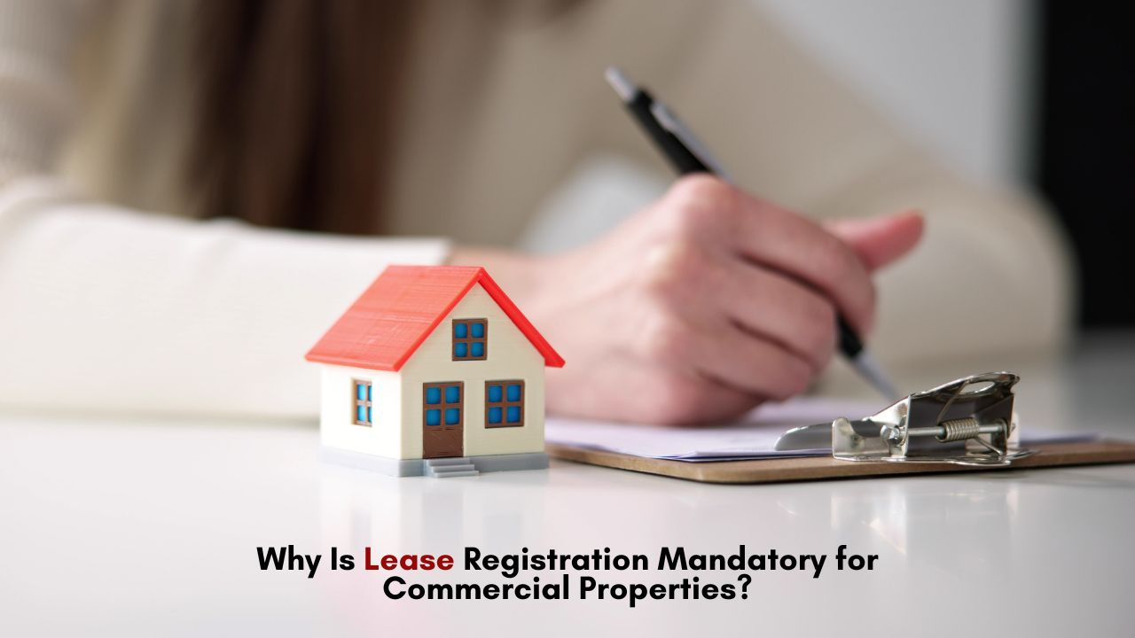

## **Introduction**

Commercial property leasing plays a crucial role in business operations, providing enterprises with the space they need to function effectively. However, simply signing a lease agreement is not enough. Lease registration is a legal requirement that safeguards the interests of both landlords and tenants. It ensures transparency, prevents disputes, and strengthens the enforceability of the agreement. Understanding why lease registration is mandatory and how it benefits businesses can help property owners and tenants comply with legal obligations while avoiding unnecessary complications.

**Ensures Legal Validity and Protection**

A lease agreement is a formal contract between a landlord and tenant outlining the terms and conditions of the property’s use. However, an unregistered lease lacks legal standing in case of disputes. Lease registration provides documented proof of the contract, ensuring that both parties are legally bound by its terms. Courts recognize only registered lease agreements as valid, making it easier to enforce rights and seek legal remedies when necessary.

Moreover, lease registration protects tenants from unlawful eviction and arbitrary rent hikes. It also safeguards landlords by ensuring timely rent payments and preventing unauthorized modifications to the property.

**Prevents Fraud and Disputes**

One of the biggest risks in real estate transactions is fraud. Unregistered lease agreements may lead to cases where multiple tenants claim rights over the same property or where property details are misrepresented. Lease registration mitigates these risks by creating a government-verified record of the transaction.

Additionally, in the event of a disagreement between the landlord and tenant, an unregistered lease may not be considered valid evidence in legal proceedings. Lease registration eliminates ambiguity and provides a clear framework for resolving disputes fairly.

**Importance of Proper Documentation**

Before registering a lease, it is essential to gather all the [**documents required for lease agreement**](https://corpbiz.io/lease-registration). These typically include:

* Proof of identity and address of both parties
* Ownership proof of the property
* Lease agreement draft with detailed terms
* Property tax receipts
* Stamp duty and registration fee payment proof

Ensuring that these documents are in order helps streamline the registration process and avoids delays or legal hurdles.

**Compliance with RERA Regulations**

The Real Estate (Regulation and Development) Act (RERA) mandates that lease agreements, especially those exceeding 12 months, must be registered to ensure transparency in real estate dealings. Failure to register a lease can lead to legal complications and potential penalties.

If a tenant or landlord faces issues related to property dealings, they can file a [**RERA complaint**](https://corpbiz.io/rera-complaint) to seek resolution. In cases where builders fail to meet commitments, a RERA complaint against builder can be lodged, ensuring accountability in commercial leasing. Lease registration serves as a crucial document in such complaints, strengthening the case of the complainant.

**Role of Lease Registration in Will and Estate Planning**

For business owners and investors, lease registration is also linked to estate planning. When a commercial property is leased out, it forms part of the assets to be passed on through a will. Will registration ensure that the property’s leasing arrangements are legally recognized and executed as per the owner’s wishes. With the advent of technology, online will registration simplify the process, making it convenient for property owners to secure their real estate holdings.

At Corpbiz, we understand the legal complexities associated with lease registration and commercial leasing. Our experts assist businesses in preparing lease agreements, gathering necessary documentation, and ensuring compliance with regulatory requirements. Whether you need help with lease registration, filing a RERA complaint, or securing your assets through [**will registration**](https://corpbiz.io/will-registration), Corpbiz provides seamless legal solutions to protect your interests.

**Conclusion**

Lease registration is not just a legal formality; it is a crucial step in protecting the rights of landlords and tenants in commercial property transactions. From preventing disputes and fraud to ensuring compliance with RERA regulations, lease registration strengthens the enforceability of lease agreements. Additionally, it plays a vital role in estate planning, making property transitions smoother. Businesses should prioritize lease registration to safeguard their investments and avoid potential legal complications.

Connect with **Corpbiz Legal Advisors** [www.corpbiz.io](https://www.corpbiz.io/) or at +91-9121230280.