Crest Teeth Whitening Strips – Achieve a Brighter Smile with The White Smiles

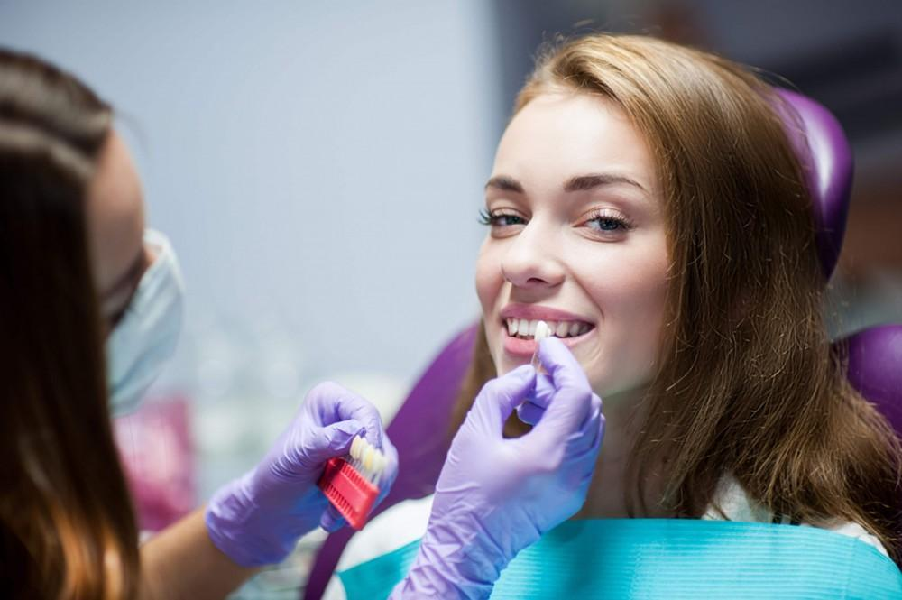

At home, we provide [Crest Whitening Strips](https://thewhitesmiles.com/shop/crest-whitening-strips-professional/), a safe and reliable way to a whiter, brighter smile. Whiter than other tooth whiteners, safer than high-bleach teeth whiteners, whitening strips painlessly and elegantly get the job done for you to wear a brighter smile in no time.

Crest Teeth Whitening Strips contain Advanced Seal Technology, which stays firmly in place without slipping. You can speak, even drink water, while whitening. Professional-strength formula penetrates deep through the enamel to remove stubborn stains without over-sensitivity, yet is gentle and safe enough for everyday use.

Available in various strengths, including [Crest 3D White](https://thewhitesmiles.com/shop/crest-whitening-strips-professional/) Professional Effects, Crest 3D White Luxe, and Crest Gentle Routine, these strips cater to different whitening needs. Crest has the perfect solution if you’re looking for quick results for a special occasion or a gradual whitening process.

Using Crest Whitening Strips is easy—wear them 30 to 60 minutes a day, depending on the product, and notice real results in three days, total whitening in two weeks.

The White Smiles offers authentic [Crest Teeth Whitening Strips](https://thewhitesmiles.com/shop/crest-whitening-strips-professional/) in the UK with ensured quality and dependability. Ready to hold your head high with a gleaming white smile. Order now for fast and safe delivery!